**Experiment No.: 1 Date:28/10/2022**

**Aim:**

Model a simple HTML file to demonstrate the use of different tags.

**CO1:**

Explore markup languages features and create interactive web pages using them.

**Procedure:**

<html>

<head>

<title>

WELCOME

</title>

</head> <body <font color="black" bgcolor="lime">

<fieldset>

<center>

<font color="blue"><h1><marquee>WELCOME</marquee></h1>

<h2>

<b><font color="black">My Website</font></b>

</h2>

<h2>

<a href="cars.html"><br>helloo!!</a>

<br><br>

<br><br></center>

</h2><h2

<ul TYPE="square">

<li>hai</li>

<li>hello</li>

<li>how are you</li>

<li>are you ok </li>

</ul>

</h2>

<h2>

Question Words

<ol>

<li>who are you</li>

<li>how are you </li>

<li>where are you from</li>

<li>how did you</li>

</ol>

</font></h2>

</fieldset>

</body>

</html>

**Output Screenshot:**

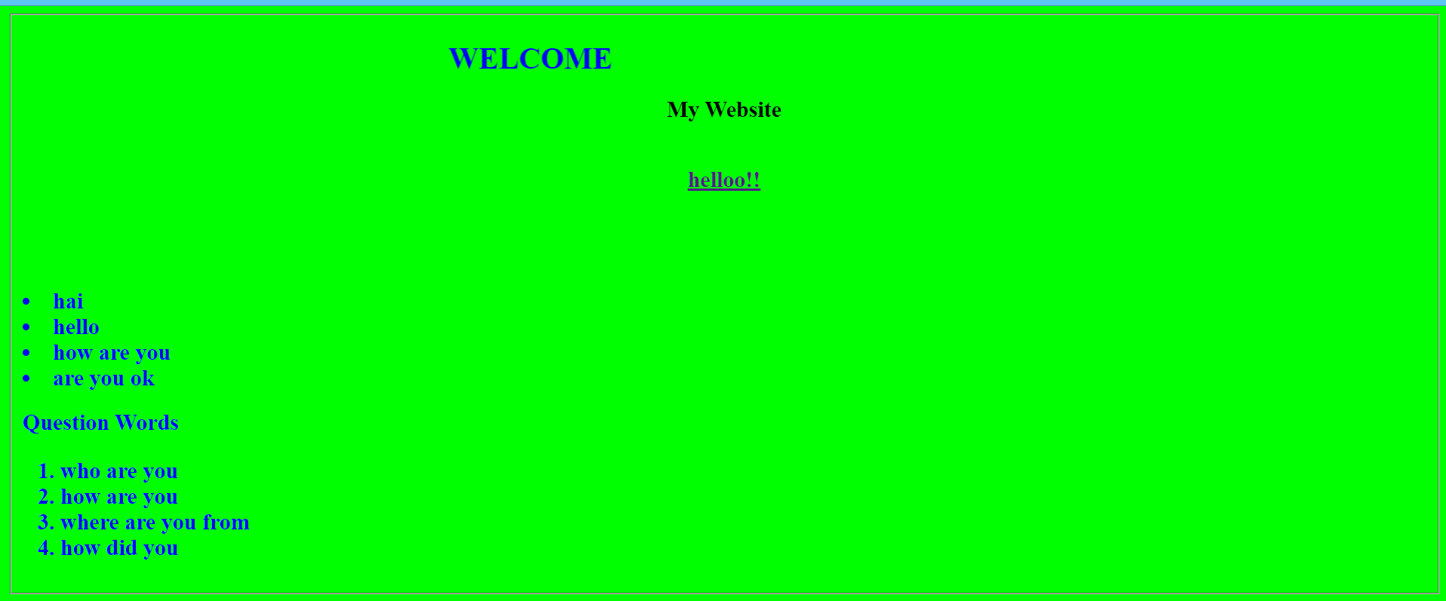

**Result**

The program was executed and the result was successfully obtained. Thus CO1 was obtained.

**Experiment No.: 2 Date:28/10/2022**

**Aim:**

Create a HTML file to link to different HTML page which contains images, tables, and also link within a page.

**CO1:**

Explore markup languages features and create interactive web pages using them.

**Procedure:**

***(Main page):***

<html>

<head>

<title>WELCOME</title>

</head> <body <font color="lime" background="https://c4.wallpaperflare.com/wallpaper/819/896/34/car-honda-nsx-nissan-gtr-r34-wallpaper-preview.jpg">

<center>

<font color="lime"><h1>WELCOME TO THE WORLD OF CARS</h1>

<h2>

<b><font color="yellow">HYRUZ GROUP Website</font></b>

</h2>

</center>

<h2>

NISSAN GTR R-34<a href="cars.html"><br>ABOUT GTR</a>

<br><br>

<br><br>

</h2><h2>

GALLERY <a href="GALLERY.html"> <br>CAR GALLERY</a><br><br>

CAR MODELS <a href="tables.html"> <br>INDIAN CAR COMPANIES</a><BR><BR>

JDM COMPANY

<ul TYPE="square">

<li>nissan</li>

<li>toyota</li>

<li>honda</li>

<li>mistibushi</li>

</ul>

</h2>

<h2>

JDM MODELS

<ul>

<li>supra mkv4</li>

<li>gtr r 34</li>

<li> honda civic</li>

<li>mazda rx7</li>

</Ul>

</font></h2>

</body>

</html>

***(Link pages):***

html>

<head>

<title>

automobiles

</title>

</head>

<body background="https://c4.wallpaperflare.com/wallpaper/985/116/48/forza-horizon-3-car-2k-nissan-skyline-gt-r-r34-wallpaper-preview.jpg" width="1000" height="600">

<font color="white"><h1>NISSAN GTR R-34</h1></font>

<font color="white"><p>The Nissan GT-R is a high-performance sports car and grand tourer produced by Nissan, unveiled in 2007.[3][4][5] It is the successor to the Skyline GT-R, a high performance variant of the Nissan Skyline. Although this car was the sixth-generation model to bear the GT-R name, the model is no longer part of the Nissan Skyline model line up since that name is now reserved for Nissan's luxury-sport vehicles. The GT-R is built on the exclusively-developed Nissan PM platform, which is an enhanced evolution of the Nissan FM platform used in the separate Nissan Skyline luxury car and the Nissan Z sports car. The GT-R abbreviation stands for Gran Turismo–Racing, obtained from the Skyline GT-R</p></font>

<img src="https://images.hdqwalls.com/wallpapers/red-nissan-gtr-r34-02.jpg" width="1700" height="800"></img>

</body>

</html>

***(Link pages2):***

<html>

<head>

<title>

</title>

</head>

<body background="https://wallpaperaccess.com/full/11207.jpg">

<h1><center> Hyruz Group Car Garage</center></h1>

<font color="white"> <marquee> <h2>It is a official website of hyruz group.This car are owned by HZ.For paid promotion contact as!!</h2> </marquee></font>

</body>

</html>

***(Link pages3):***

<html>

<head>

<title>tables</title>

</head>

<center><body bgcolor="YELLOW"><h1>CAR BRANDS</h1></center>

<center>

<table border="5" height="600px" width="1300px" bordercolor="black"cellpadding="10"></center>

<tr>

<th>COMPANY NAME </th> <th>MODEL 1</th><th>MODEL 2</th><th>MODEL 3</th><th>MODEL 4</th><th>MODEL 5</th>

</tr>

<tr>

<th> Maruthi</th><td>Alto800</td><td>WagonR</td><td>Swift</td><td>S-Presso</td><td>Grand vitara</td>

</tr>

<tr>

<th>Toyota</th><td>Innova</td><td>Fortuner</td><td>Supra mkv</td><td>Glanza</td><td>Land cruiser</td>

</tr>

<tr>

<th> Honda</th><td>City</td><td>Jazz</td><td>Amaze</td><td>WRV</td><td>BRV</td>

</tr>

<tr>

<th> Tata </th><td>Harrier</td><td>Saffari</td><td>Tiago</td><td>Punch</td><td>Indica</td>

</tr>

</table>

</body>

</html>

**Output Screenshot:**

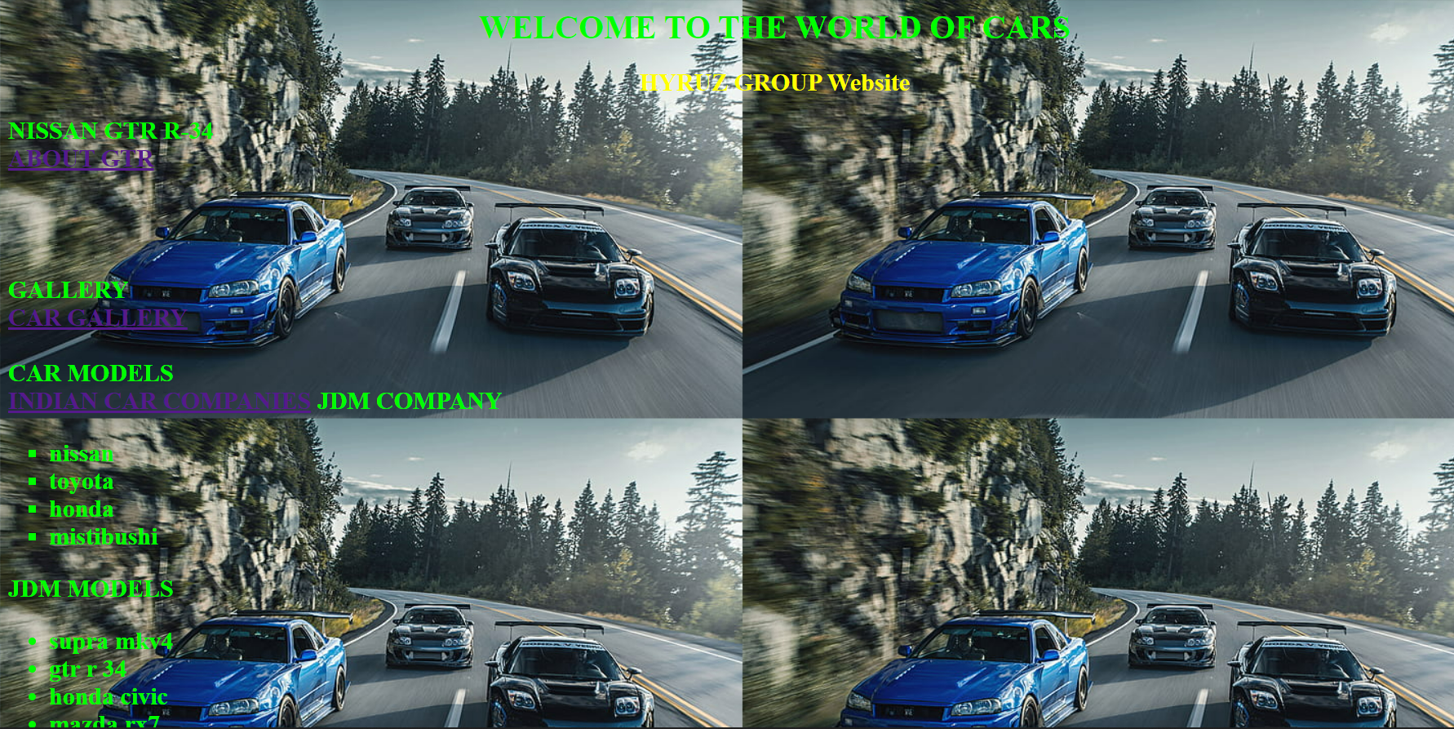

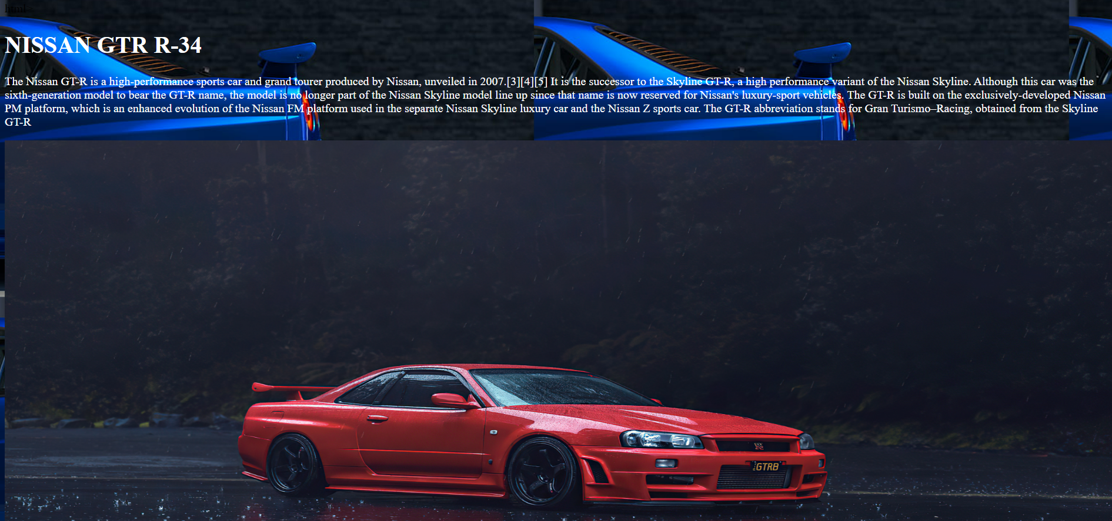

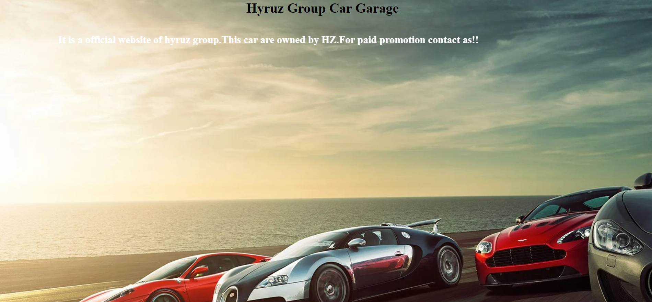

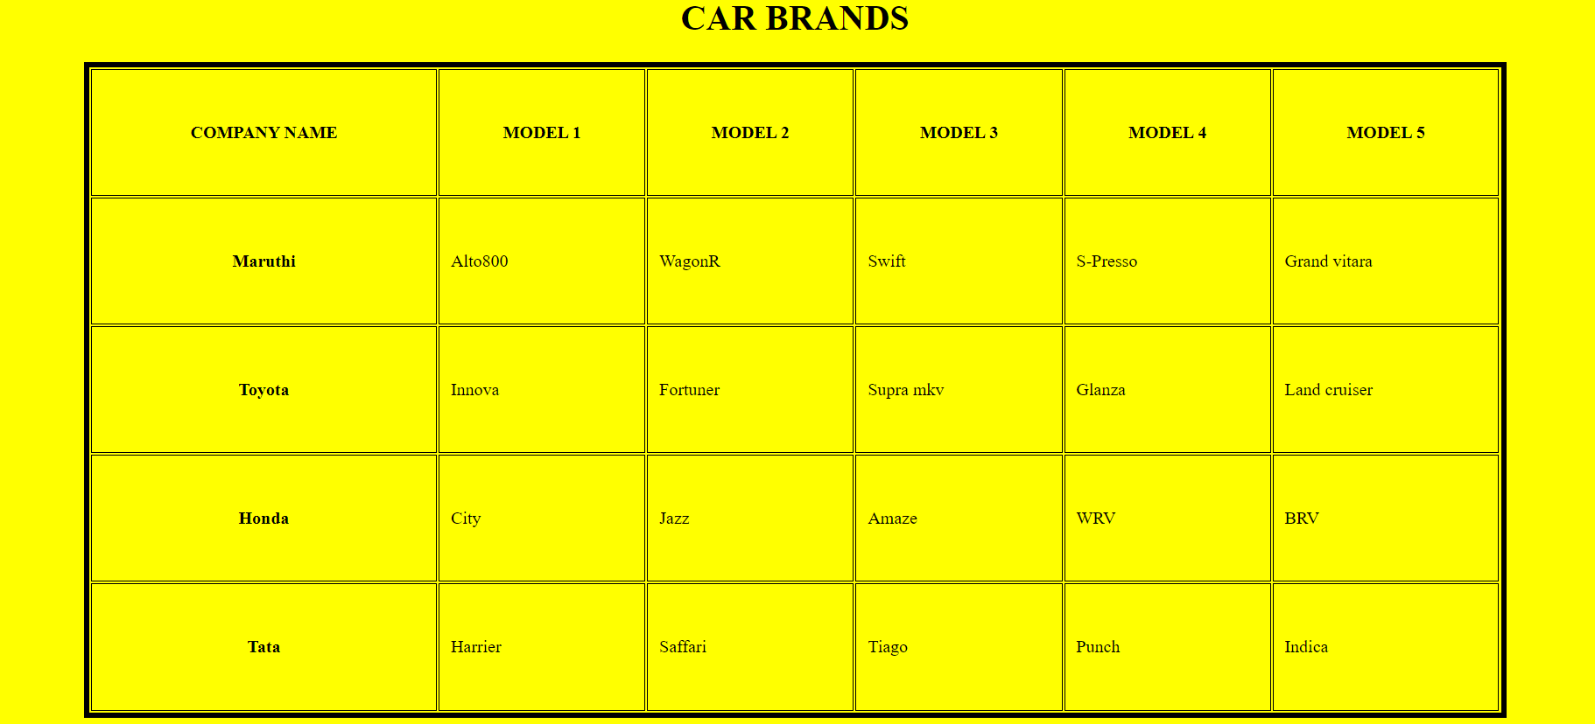

**Result**

The program was executed and the result was successfully obtained. Thus CO1 was obtained.

**Experiment No.: 3 Date:28/10/2022**

**Aim:**

Create a HTML page with different types of frames such as floating frame, navigation frame & mixed frame.

**CO1:**

Explore markup languages features and create interactive web pages using them.

**Procedure:**

***Navigation Frame:***

<html>

<head>

<title>Example of HTML Frames using row attribute</title>

</head>

<frameset cols = "50%, 50%">

<frame name = "top" src = "gallery.html" />

<frame name = "main" src = "cars.html" />

</frameset>

</html>

***Floating Frame:***

<html>

<head>

<title></title>

</head>

<body>

<h1>Floating Frame</h1>

<iframe name='floating_frame' src='difftag.html' width="3000" height="1500">

</iframe>

</body>

</html>

***Mixed Frame:***

<html>

<frameset rows="25%,75%">

<frame src="GALLERY.html" />

<frameset cols="25%,75%">

<frame src="tables.html" />

<frame src="difftag.html">

</frameset>

</frameset>

</html>

**Output Screenshot:**

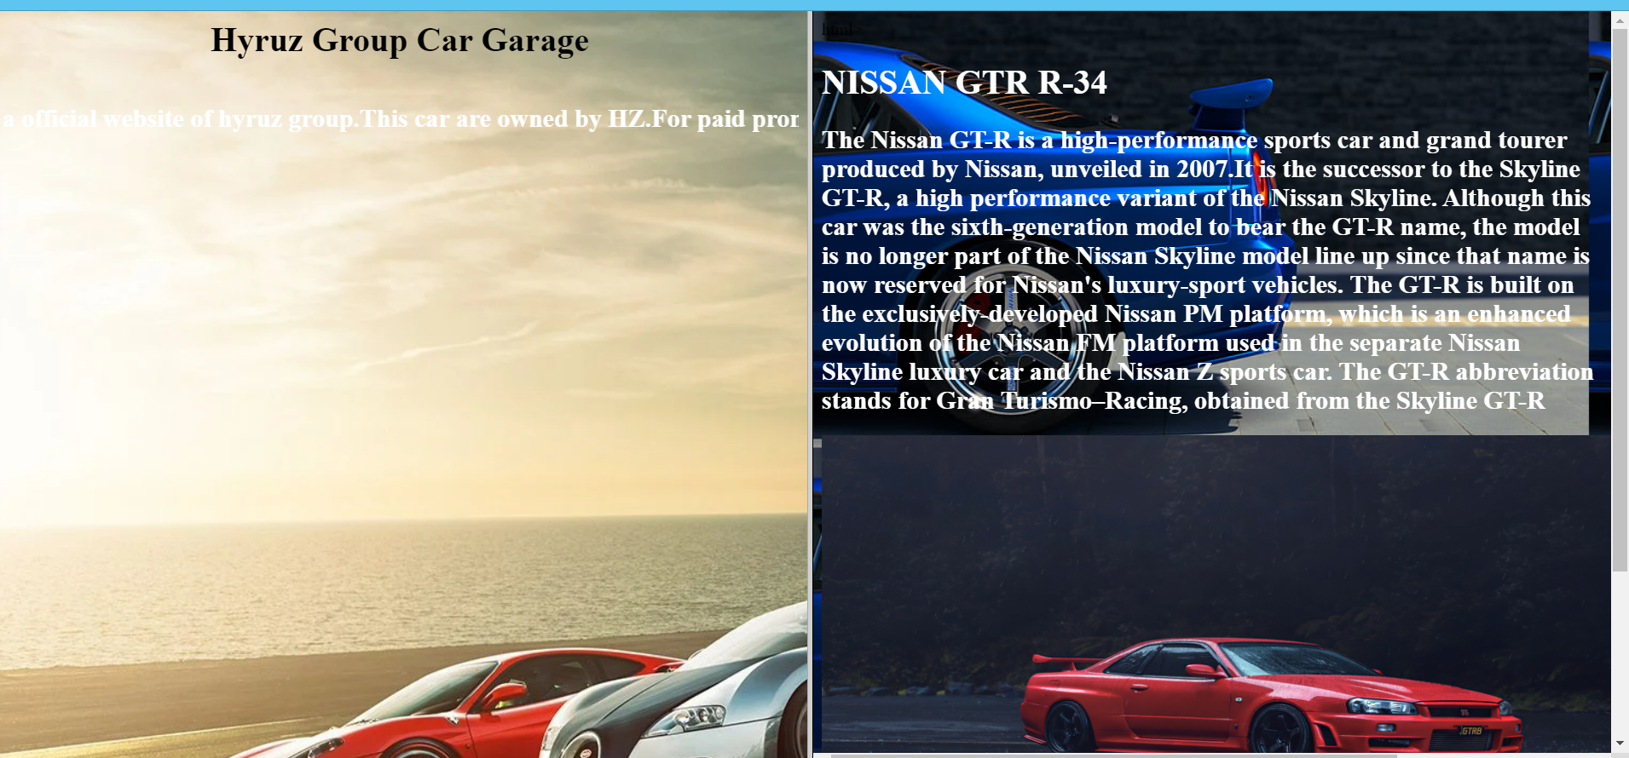

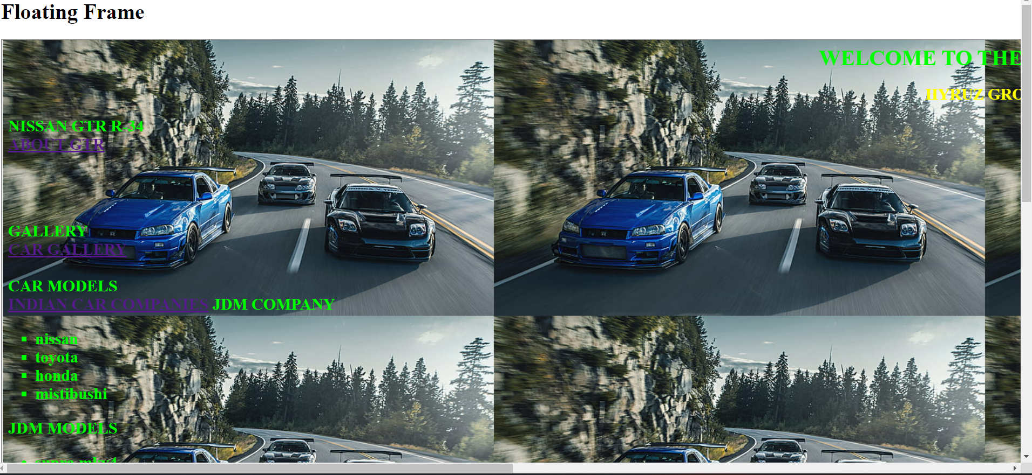

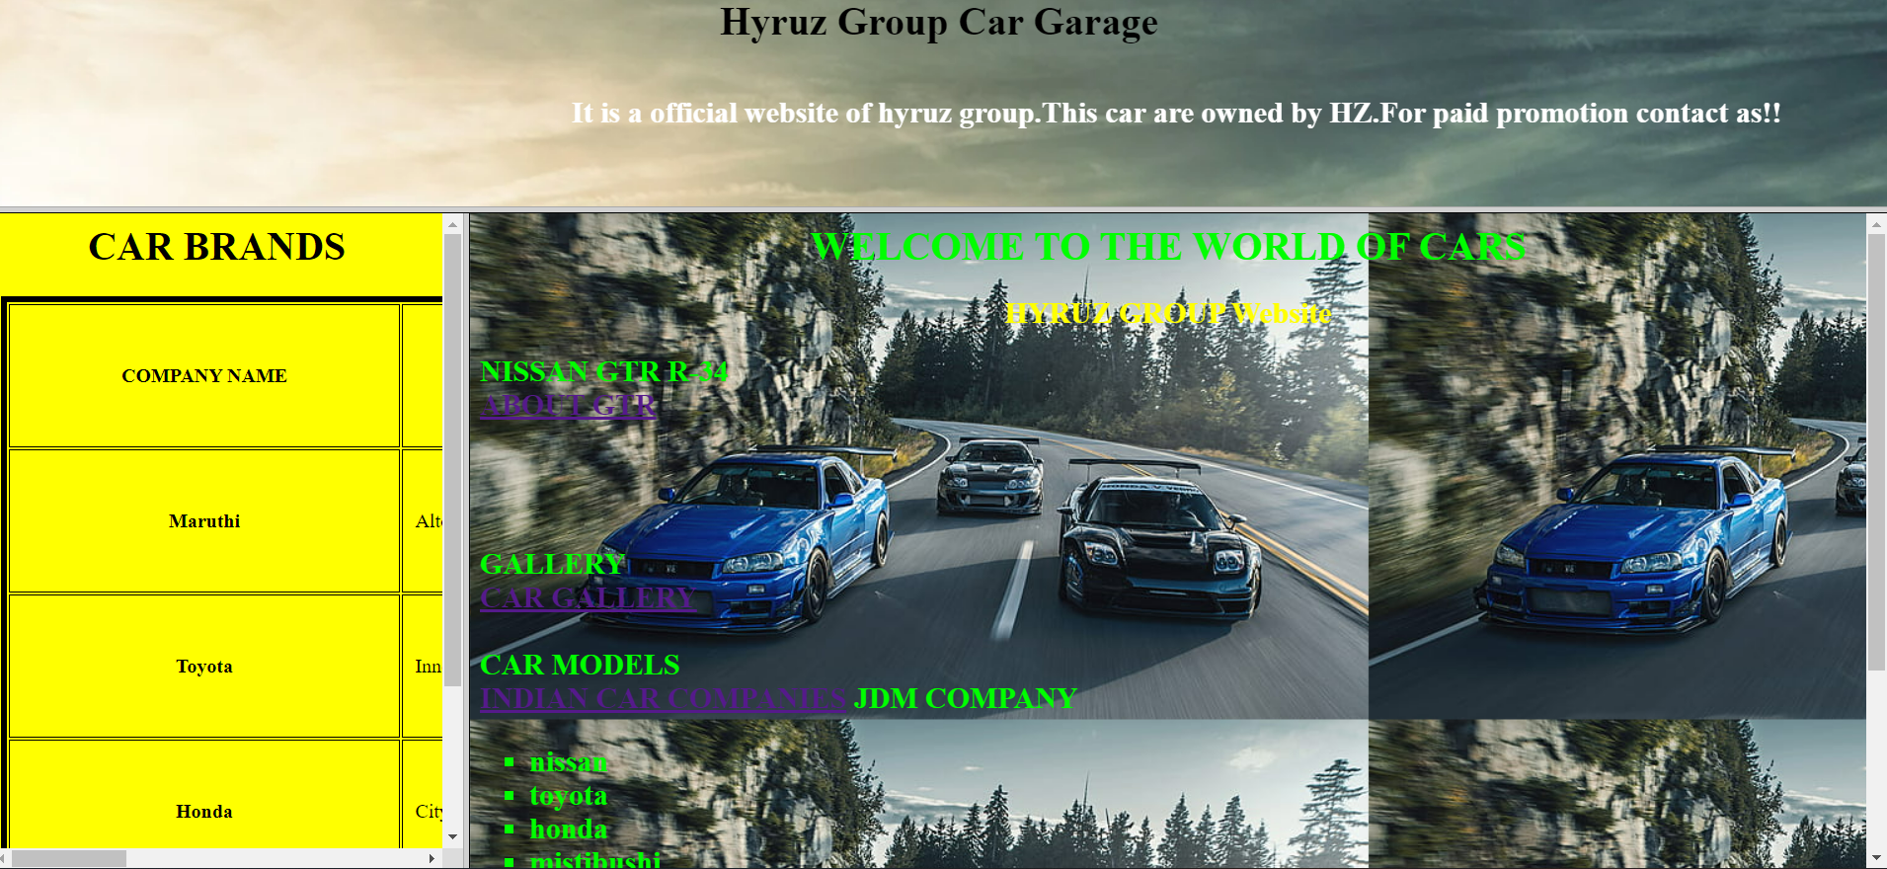

**Result**

The program was executed and the result was successfully obtained. Thus CO1 was obtained.

**Experiment No.: 4 Date:28/10/2022**

**Aim:**

Analyze CSS by applying the different styles using inline, external & internal style sheets in a HTML file.

**CO1:**

Explore markup languages features and create interactive web pages using them.

**Procedure:**

<html>

<head>

<style>

h2{color:white;

}

p{color:black;

}

</style>

<link rel="stylesheet" href="css1.css">

</head>

<body>

<h1 style="color:silver";"font_size:12px";><u><b>Inline,Internal,External CSS</b></u></h1>

<h2><u>Inline CSS:</u></h2> <p>Requires the style attribute placed inside an HTML element.<br></p>

<h2><u>Internal CSS:</u></h2><p> Requires the tag style element placed inside the head section of an HTML file.<br></p>

<h2><u>External CSS:</u></h2> <p>Requires the link element placed inside the head section of an HTML file.</p>

</body>

</html>

***External css:***

body {

background-color:purple;

}

h1{

text-align:center;

font-size:60px;

}

h2{

font-size:40px;

}

p{

font-size:20px;

}

**Output Screenshot:**

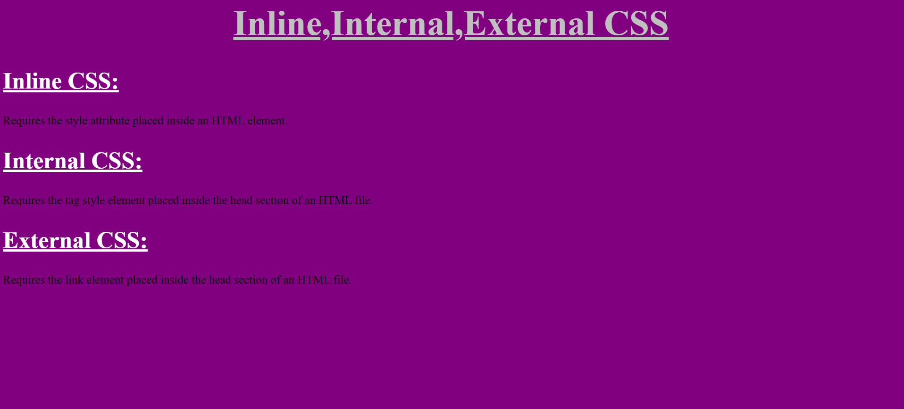

**Result**

The program was executed and the result was successfully obtained. Thus CO1 was obtained.

**Experiment No.: 5 Date:28/10/2022**

**Aim:**

Demonstrate a registration form using HTML.

**CO1:**

Explore markup languages features and create interactive web pages using them.

**Procedure:**

<html>

<head>

<title>

Application Form

</title>

</head>

<body background="https://c0.wallpaperflare.com/preview/391/321/157/botany-dark-green-plants-fern-foliage.jpg">

<form action="/login.php">

<h1> <center><font color="7F7F7F">Student Registration Form </font> </center><h1>

<table style="color:white"width="30%"height="60" align="center" border="7" bordercolor="7F7F7F" cellpadding="10">

<tr>

<th>First name&nbsp; <input type="text" name="text"></th></tr>

<tr><th>Last name&nbsp; <input type="text" name="text"></th></tr>

<tr><th>Address&nbsp;<textarea rows="1" cols="20"></textarea></th></tr>

<tr><th>Previous Institution&nbsp;<input typr="text" name="college"></th></tr>

<tr><th>Gender&nbsp;&nbsp;

<input type="radio" name="gender" value="male"> Male<br>

&nbsp;

&nbsp;

&nbsp;

&nbsp;

&nbsp;

&nbsp;

&nbsp;

&nbsp;

&nbsp;

&nbsp;

<input type="radio" name="gender" value="female"> Female</th></tr>

<tr><th>Date of Birth&nbsp;&nbsp;&nbsp;

<input type="date" name="date"></th></tr>

<tr><th> E-maili&nbsp; &nbsp;&nbsp;<input type="email" name="email"></th></tr>

<tr><th> Mobile number<input type="tel" name="number"></th></tr>

<tr><th>District&nbsp;&nbsp;&nbsp;&nbsp;&nbsp;&nbsp;&nbsp;

<select name="District">

<option selected>Kottayam</option>

<option selected>Idukki</option>

<option selected>Kollam</option>

<option selected>Kannur</option>

<option selected>Thrissur</option>

<option selected>Select district</option>

</th></tr>

<tr><th> <input type="submit" value="SUBMIT">

<input type="reset" value="RESET"></th></tr>

</select>

</table>

</form>

</body>

</html>

**Output Screenshot:**

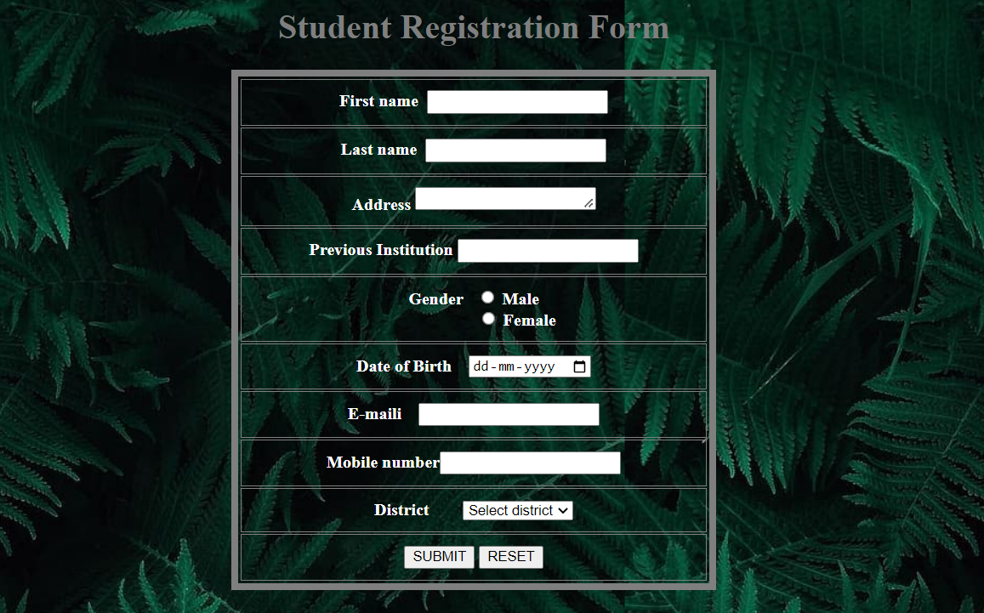

**Result**

The program was executed and the result was successfully obtained. Thus CO1 was obtained.

**Experiment No.: 6 Date:28/10/2022**

**Aim:**

Create a resume.

**CO1:**

Explore markup languages features and create interactive web pages using them.

**Procedure:**

<html>

<head>

<link rel="stylesheet" href="ress.css">

</head>

<body>

<center><h2>RESUME</h2></center>

<table width="500" height="600"align="center">

<tr>

<th>

<img class="profileimg" src="https://media.istockphoto.com/vectors/man-in-fashion-suit-template-for-web-empty-face-of-business-man-vector-id1226652118?k=20&m=1226652118&s=612x612&w=0&h=3PKIOmE8S71ZOLKpFJKIy__iRDPDhr9TuECndyaF2mQ="></th>

<td class="prof"> <ul><br>

Name:Sahid Siddik<br>

Contact:09876543211<br>

Address:Kottayam<br></td></tr>

</ul>

<tr><th><p class="skill">skills</p></th>

<td class="sk"> <ul><br>

<li>c</li>

<li>Python</li>

<li>Designing</li>

<li>Programming</li>

<li>Computer Science</li>

</ul></td></tr>

<tr><th>

<p class="head">Education institution</p></th>

<td class="educ"><ul>

<a href="https://sgcaruvithura.ac.in/">

<li> SGC ARUVITHURA </li>

</a>

</ul></td></tr>

<tr><th>

<p class="head">Certificates</p></th>

<td class="cert"><ul>

<li>Python</li>

<li>AWS</li>

</ul></td></tr>

<tr><th>

<p class="head">Extracariculars</p></th>

<td class="ext"><ul>

<li>Recycling Club</li>

<li>Gardening Club</li>

<li>Book Club</li>

</ul></td></tr>

</table>

</body>

</html>

body{

background-image:url('https://cdn.pixabay.com/photo/2015/12/01/15/43/black-1072366__340.jpg');

}

body{

color: white;

margin-center:220px;

}

.profileimg{

max-width: 80px;

height: 80px;

}

.prof{

background-color:black;

}

.sk{

background-color: black;

}

.educ{

background-color: black;

}

.cert{

background-color: black;

}

.ext{

background-color: black;

}

**Output Screenshot:**

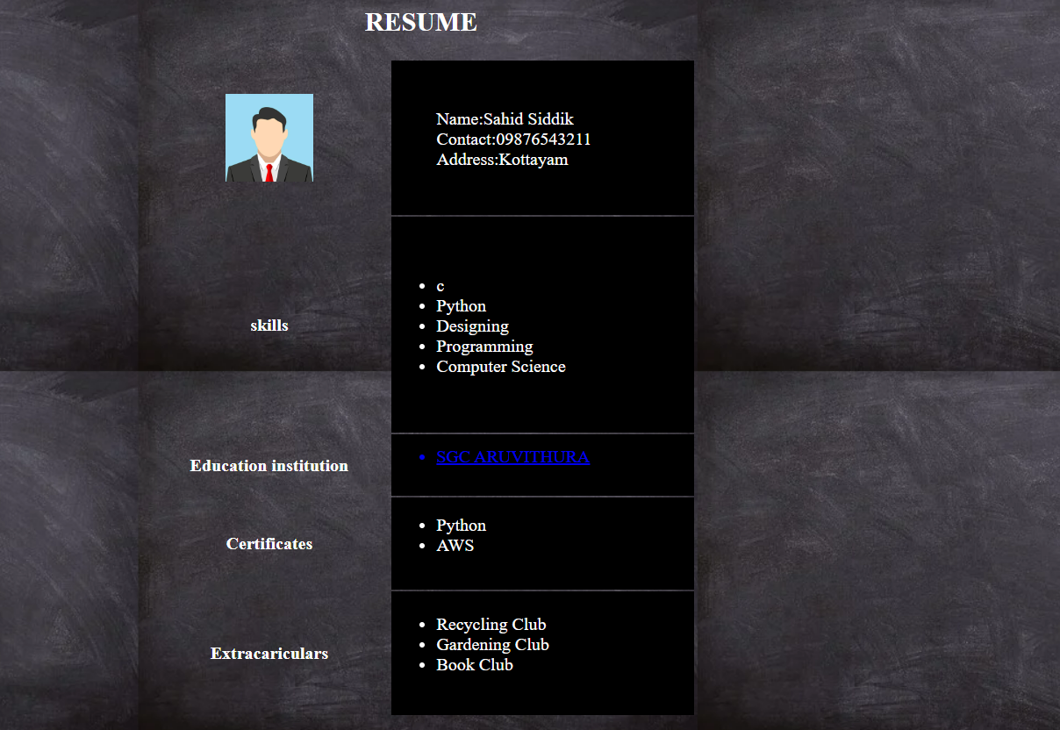

**Result**

The program was executed and the result was successfully obtained. Thus CO1 was obtained